**Bitbucket Configuration with SourceTree**

Manoranjan Acharjya

Feb 01, 2018

**Contents**

**Overview** **3**

**Terminologies and Usages** **3**

**Configure SourceTree** **4**

**Access your Bitbucket Server** **4**

**Create a repository in Bitbucket** **4**

**Clone a repository from Bitbucket** **7**

**Checkout Source from Bitbucket** **10**

**Commit/Push changes to Master Repository** **13**

**Modify, Merge and Push common files by multiple developers** **18**

**Pull/Merge changes to master repository through branches** **19**

**Appendices and Annexes** **23**

# 

# Overview

This document provides a step by step approach to configure BitBucket server with SourceTree to manage all the APIs. If you do choose to use SourceTree as a GUI Git client, you'll need to add your BitBucket credentials to SourceTree. SourceTree provides an interface that gives you the same capabilities you have with Git without the need to use command line. It is highly recommended to use sourcetree as it provides a graphical user interface to work.

# Terminologies and Usages

1. Remote Repository - This is the place where all the committed files are placed after pushing in to repository. It acts as a master repository (Bitbucket server)
2. Local Repository - This is the place in your local machine from where you can commit all your changes and push to master repository.
3. Commit - Store all your files to a state/revision on your local repository. These commits serve as nodes.
4. Branch - It is a kind of sub folder which refers how bitbucket branches of nodes when user commits their files.
5. Merge - It will combine two branch heads together into one branch (usually with master branch).
6. Push - uploads or moves all the committed changes to master repository.
7. Fetch - Download all the committed files from the master repository to your local repository and does not merge your changes.
8. Pull - Download all the committed files from the master repository to your local repository and merge your most recent changes.

[**Click here for Part 2 of the Overview : API Definition**](https://drive.google.com/open?id=15zntQG03G91Ufm6J2J1zslNY0uCpRgDdj-X0xJdxMCM)

[**Click here for Part 1 of the Overview: Introduction**](https://drive.google.com/open?id=1znz412R2ZmoPz5DLnMivaccx2U0pyP9x1Ojh05H5cWM)

# Configure SourceTree

1. Install sourcetree (version - SourceTreeSetup-2.3.1.0) from the following URL

[Download SourceTree](https://www.sourcetreeapp.com/)

1. After successfully installed, open sourcetree and go to tools -> options -> Authentication tab and provide your bitbucket credentials. (Refer below image)
2. Then click continue and your source tree setup will be done.

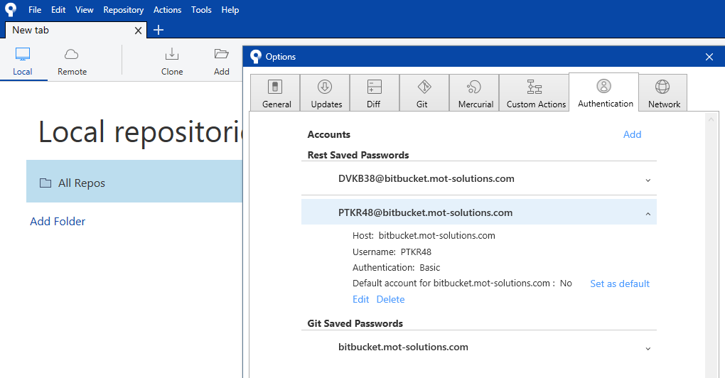

# Access your Bitbucket Server

Access bitbucket server by login with your bitbucket credentials to [BitBucket Development](https://bitbucket.mot-solutions.com/projects/MULEDEV), [BitBucket UAT](https://bitbucket.mot-solutions.com/projects/MULEUAT) and [BitBucket Production](https://bitbucket.mot-solutions.com/projects/MULEPROD) environment based on your requirement.

# Create a repository in Bitbucket

If you want to proceed and commit your changes through GIT, then configure using terminal.

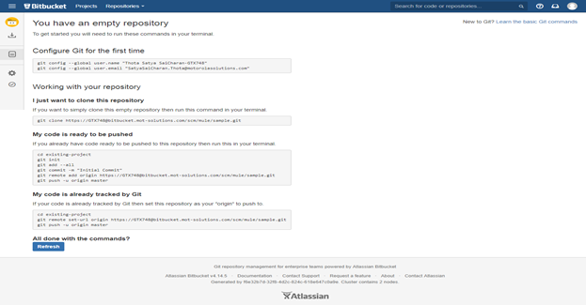

Once you are in a remote server (i.e. Bitbucket server) and if you have permission from Admin to create a new repository in bitbucket server then follow the steps mentioned in the below images.

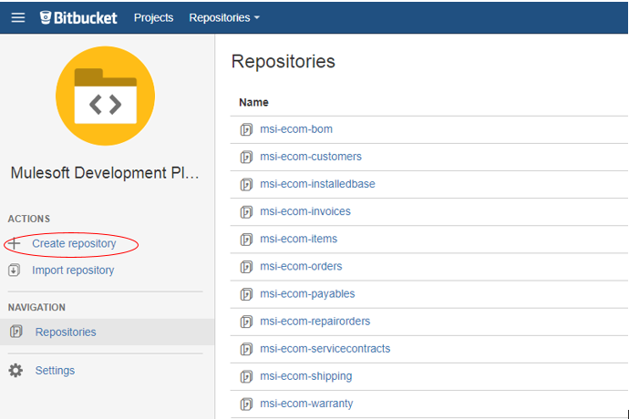

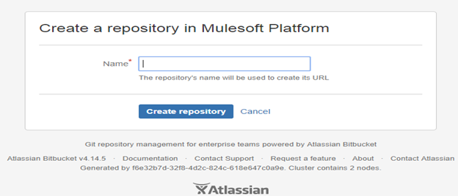

**Note:** There are two ways to download source code from bitbucket repository. One is using Clone option and another one is using Checkout option.

# Clone a repository from Bitbucket

Using source tree we can clone a remote repository to our local repository. In bitbucket, once you create a repository, then select the repository and click on the “Clone” link as mentioned in the below image.

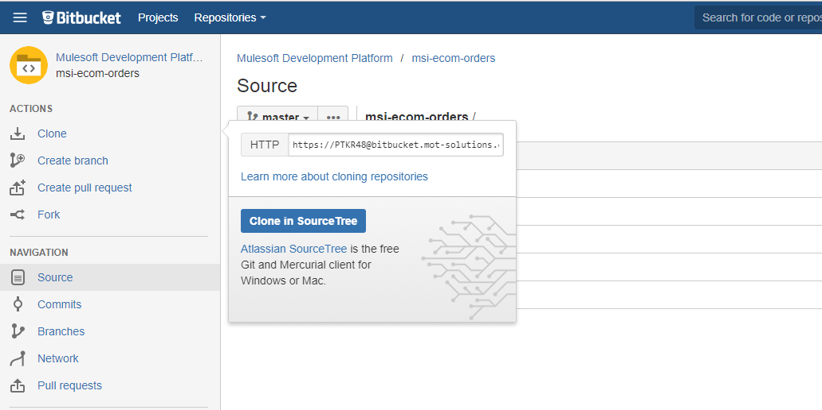

After click on the “Clone in SourceTree” link in the window, a tab in the source tree will be opened automatically and it will ask for the destination folder in your local machine to clone the remote repository.

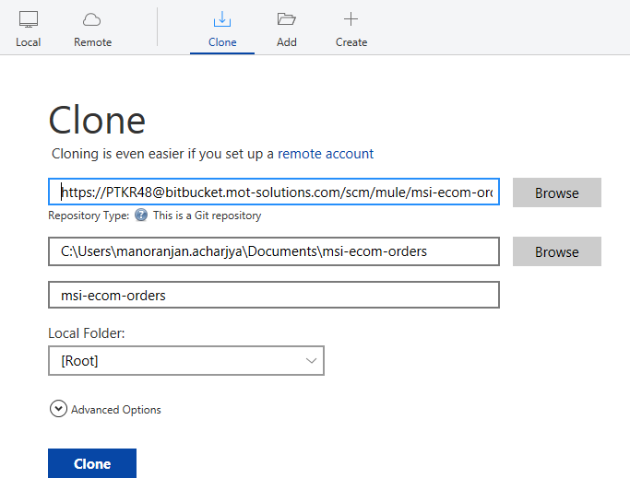

When you click on the Clone button then a folder with all the source code will be created in your local path. (Refer below Image).

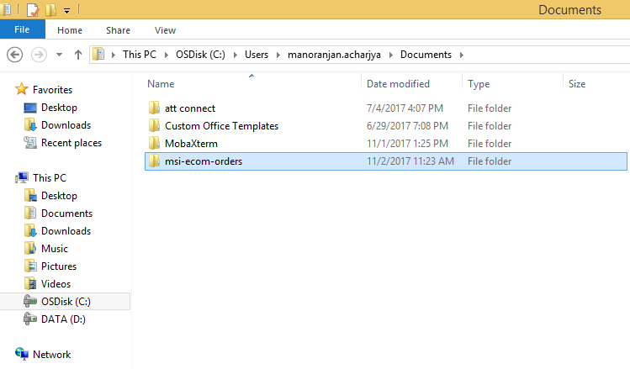

In the above step, you will be able to clone your remote repository to your local computer. Cloning a repository locally creates a file directory on your computer that will be in sync with your remote repository. Now you can add/modify your files/folders to your local repository created through sourcetree.

**Note:** While proceeding with the configuration after providing bitbucket credentials, if you get error like “**This is not a valid source path/URL**” (refer the below image) and you are not able to clone the repository in sourcetree then please follow the below steps.

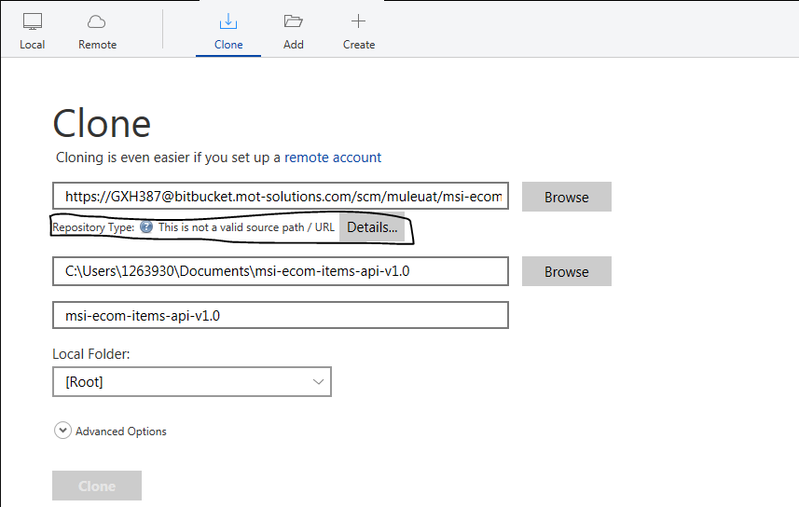

**Steps:** Open sourcetree and then go to tools -> options -> Click on Git Tab -> Update Embedded Git.

# Checkout Source from Bitbucket

In the above screen, we have created few remote repositories. Once you create your own repository, select the repository and go to source view and click on the “Checkout in Source Tree link to download the source code in your local machine. Before clicking on the “Checkout in Source Tree” link, make sure that your sourcetree is open. Provide your local path as mentioned in the below screen, a tab will be opened in sourcetree and the your source code will be downloaded in the local folder.

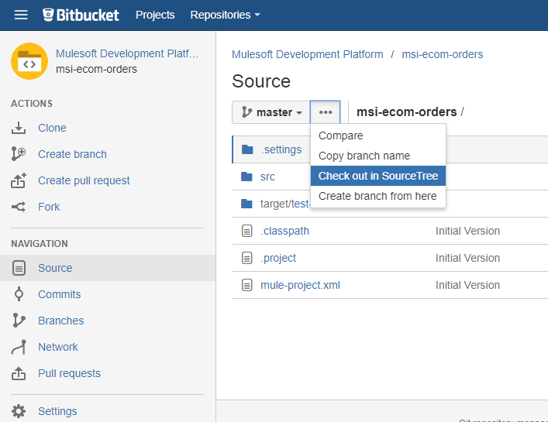

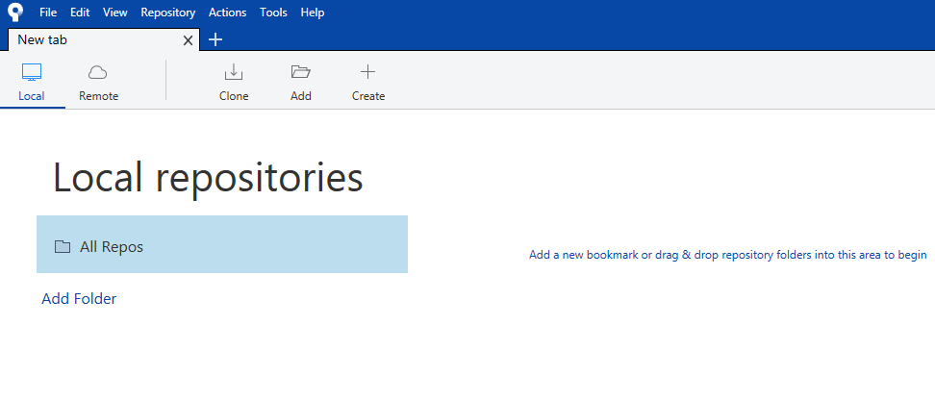

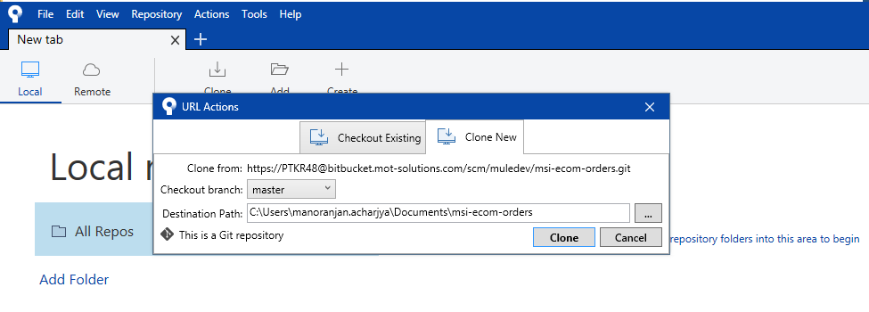

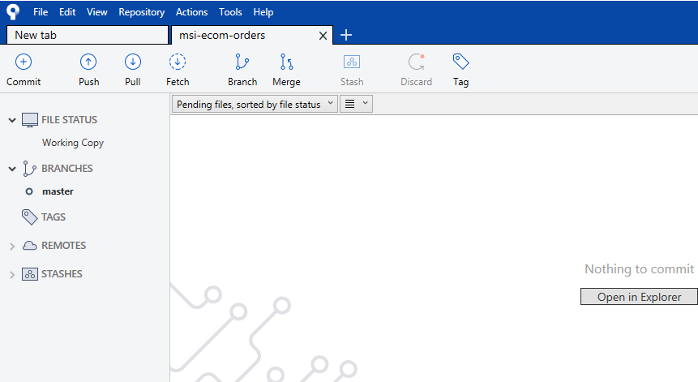



# Commit/Push changes to Master Repository

As soon as you add or modify your changes to your local repository, the new changes will be in sync and reflected in your source tree tab. All the changes will be visible in the “Unstaged files” section of the source tree tab. Here I have modified two java files and these two files are visible in the Unstaged files section.

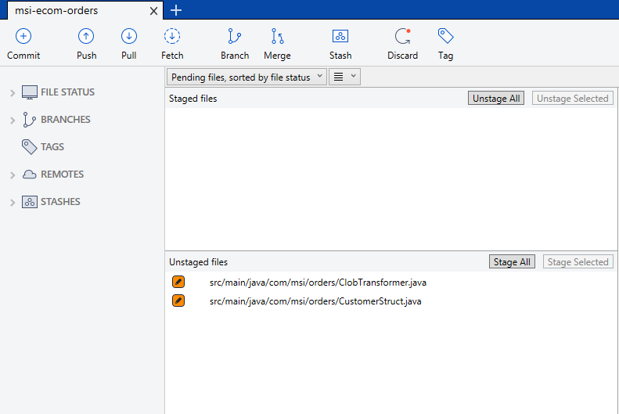

When you will click on Stage All or Stage Selected button depends on your files to be pushed to commit, all the files will be moved into “Staged files” section of the source tree tab. You can unstage files also if you don’t want to push your changes to commit. (Refer below Image).

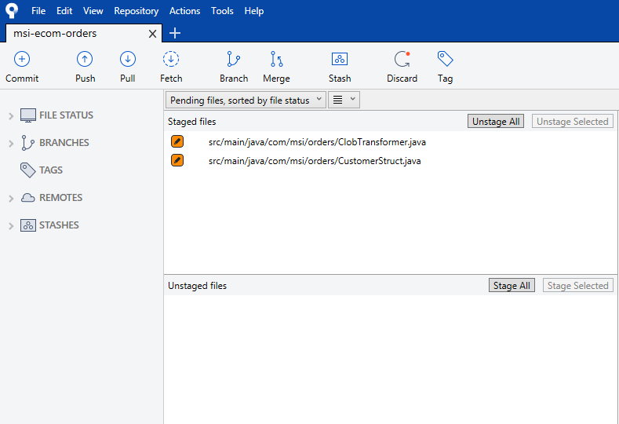

Click on Commit button (Refer below image) by putting proper message in the comment box. If you will select the “Push changes immediately to origin/master” checkbox then all changes will be pushed to master repository after commit automatically. Otherwise you have to push the changes after the commit.

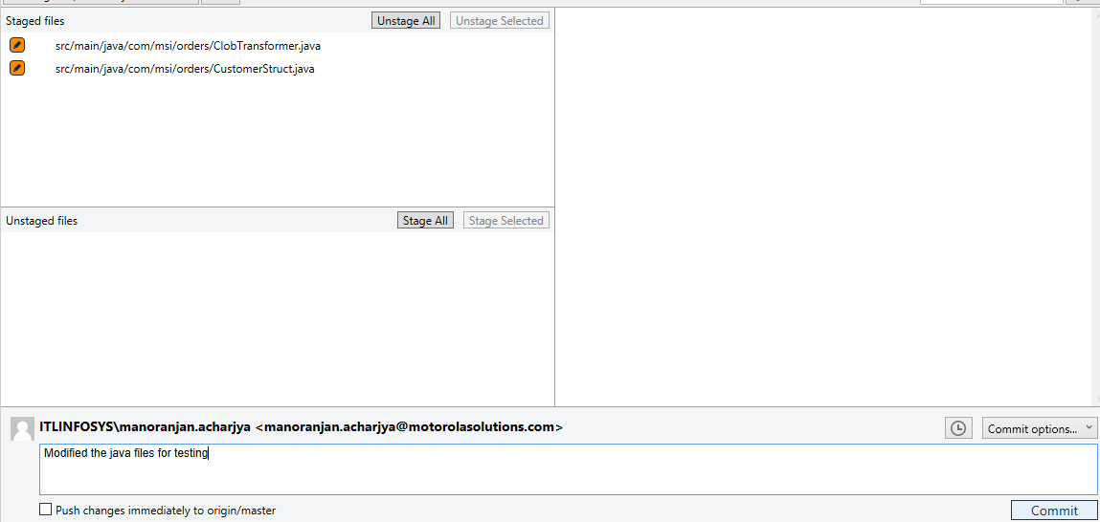

Click on the push button to move your changes into master repository.

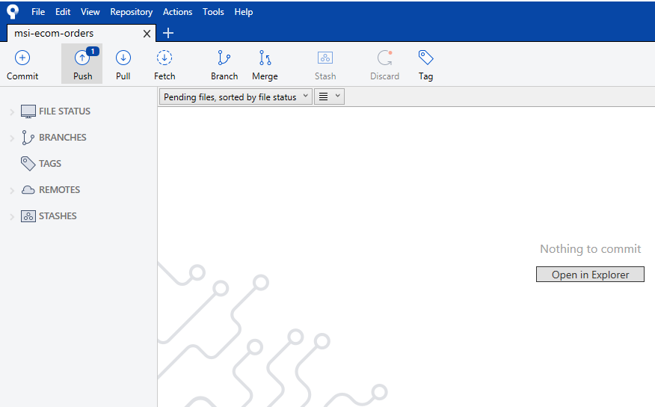

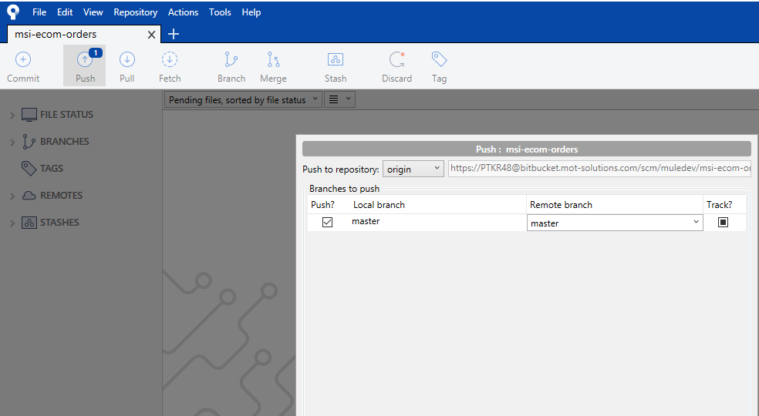

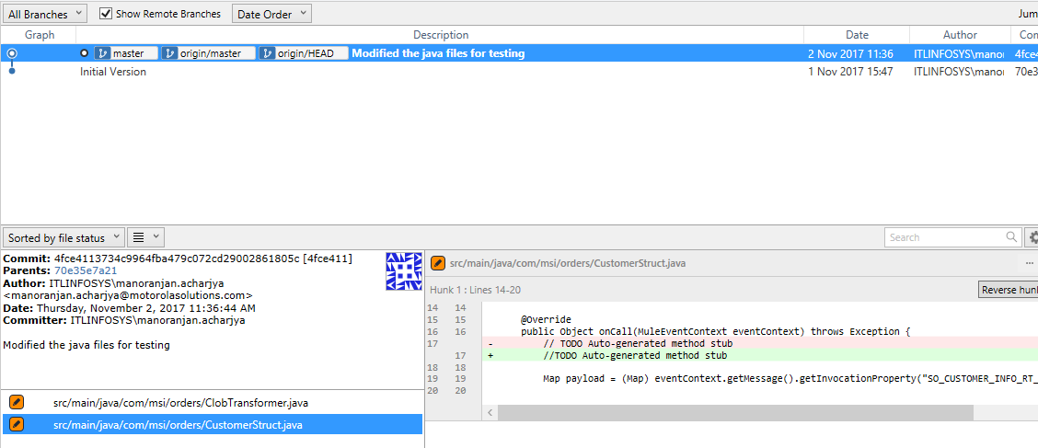

Here you can see that the two modified java files have been moved to remote repository with proper comments.

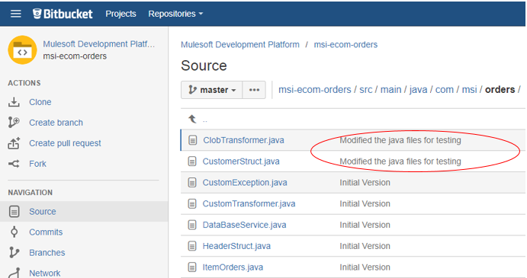

# Modify, Merge and Push common files by multiple developers

When multiple developers are working on a common source file and trying to commit and push the changes to master repository then they will implement this using Pull/Merge feature of sourcetree.

### Steps:

1. Let’s say developer “A” has checked out the source code into his local repository master branch and makes some changes.
2. At the same time developer “B” has also checked out the source code into his local repository master branch and makes some changes to the same file in which developer “A” is working.
3. Developer “A” has finished his work and pushed the changes to the master branch.
4. Now developer “B” has also finished his changes and when clicked on push button he will get some error (because the code is not sync with repository).
5. Developer “B” needs to click on fetch button to get the latest code.
6. After that, developer “B” should click on Pull button to merge all his changes to the latest code.
7. Now when developer “B” click on Push button, all his changes will in updated along with developer “A” changes into the master repository.

# Pull/Merge changes to master repository through branches

Here I have created a new branch called Test in bitbucket server. When we create a new branch in bitbucket, then all the source code from master will be copied to the new branch at the time of creation itself.

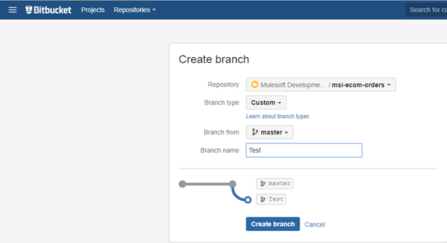

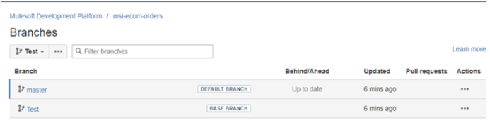

After creating a new branch in bitbucket, when I click on Fetch button in sourcetree tab, the newly created branch is getting displayed in the sourcetree tab. (Refer below image).

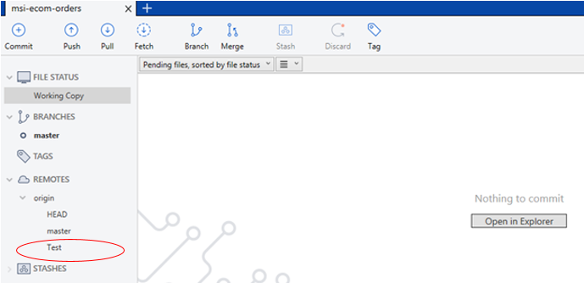

Here I will modify one file and commit in sourcetree tab. After committing I will push that changes to the newly created branch.

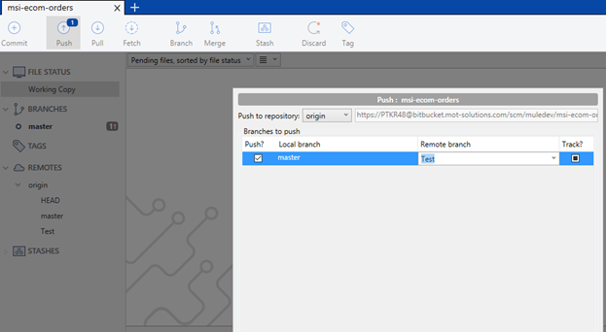

Once my new changes are pushed into Test branch then I have created a pull request to pull and merge the changes from Test branch to master branch.

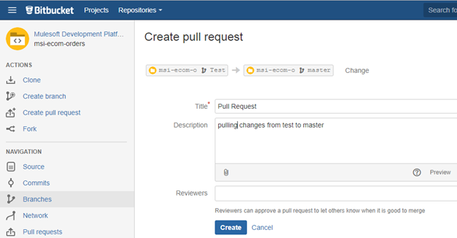

Once the pull request has been created, I have clicked on Merge button to merge the changes.

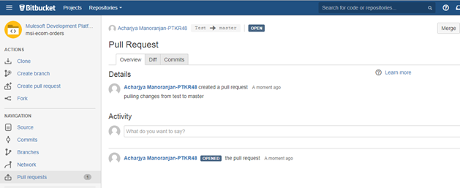

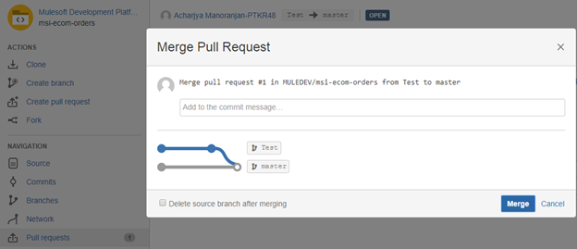

In sourcetree tab, you can see my changes are ready to merge from Test to master. Click on Pull button, my new changes will be merged to master repository.

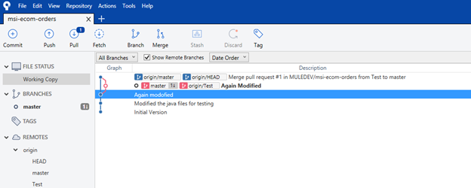

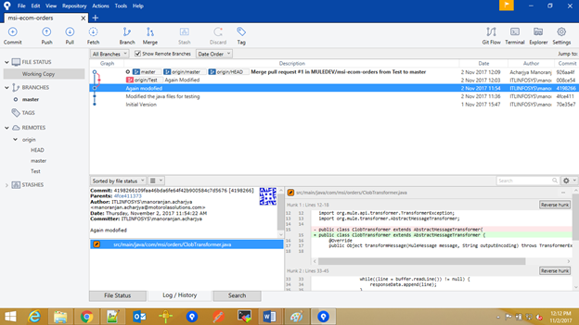

After your changes have been merged you can delete your new remote branch either from source tree tab or from bitbucket.

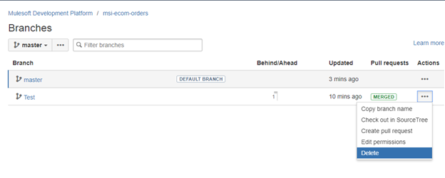

# Appendices and Annexes